**Business as Usual**

Local Business and the Impact of Industrialization in Lancaster County

Contents

* Industries of Lancaster County Prior to 1800
  + Journal of the Lancaster County Historical Society
* The Lancaster Long Rifle
* Safety Buggy Works
  + Metal Stencil
* Demuth Snuff Crock
* Hubley Airplane Toy
* Criminalization of Unionization
  + Indictment of Edward N. Seals – Aiding a Strike on the Railroad
* Watt & Shand print block
* The View over Chickies Rock
  + The Low Grade Railroad Line

Questions to Consider

* How did Lancaster experience industrialization?
* Which of these aspects of industry are unique to Lancaster County?
* How have local businesses and industries changed and adapted, from pre-1800 to the present?

**Industries of Lancaster County Prior to 1800**

Journal of the Lancaster County Historical Society

“Lancaster County of the eighteenth century was a quickly growing community which gave early promise of its continued virility and importance.”

Questions to Consider

How did available raw materials impact industry?

What were some of the major sectors of the local economy at this time?

The Lancaster Long Rifle

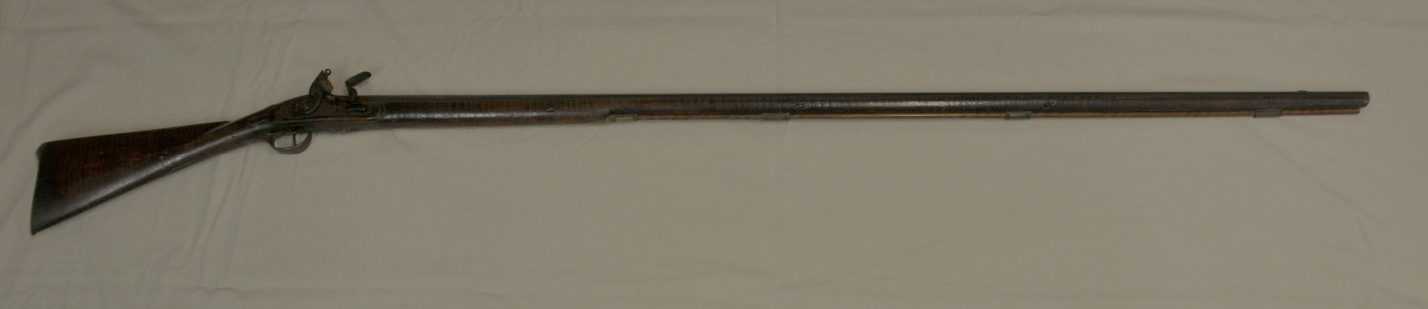

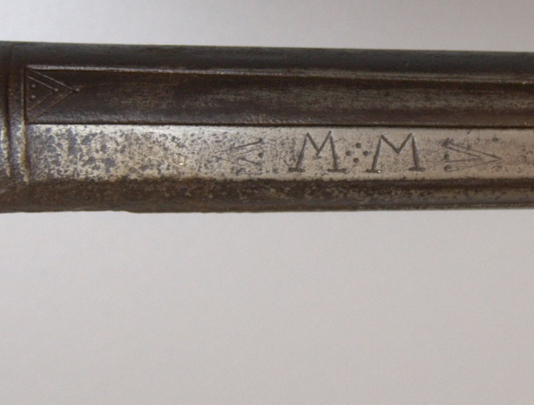

Flintlock musket, engraved "M. M." on top of barrel. Undetermined intaglio stamp on side, "McDonogh?" engraved bird designs behind hammer strike.

This rifle was made by Martin Mylin in the mid 18th century.

The long rifle, a Pennsylvania German creation, appears in the Lancaster area in the early eighteenth century. Long rifles, among the first commonly used rifles for hunting and warfare, are characterized by an unusually long barrel that uses “rifling,” or spiral grooves in the bore. The rifling gave the projectile, commonly a round lead ball, a spiraling motion, increasing the stability of the trajectory, which meant dramatically improved accuracy over the more commonly available smooth bore muskets of the period.

Questions to Consider

How would this impact the Lancaster economy?

When would demand for these products increase?

**Safety Buggy Works**

Metal Stencil

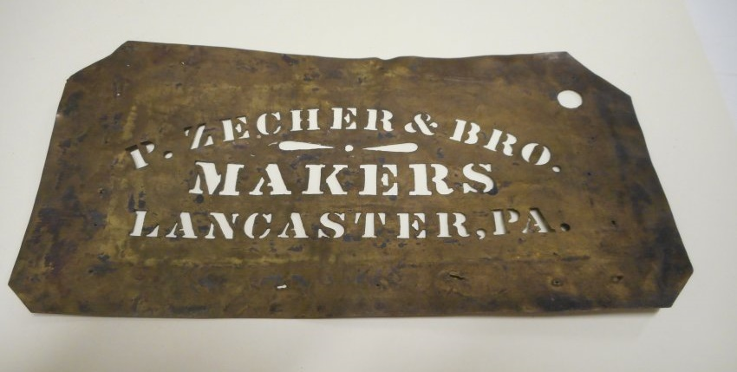

Metal stencil, "P. Zecher & Bro. / Makers / Lancaster, PA" from Safety Buggy Works

4.25 x 8.375 inches

The P. Zecher & Bro factory was located on 426 N Queen Street, according to the Railroad, County, and Township Map of Pennsylvania, and Business Directory of the Representative Business Houses published in 1891 by P.J. Hannifan & Co.

Questions to Consider

How has this sector of Lancaster County’s economy remained?

How does this represent a different kind of advertising from what we see today?

Demuth Snuff Crock

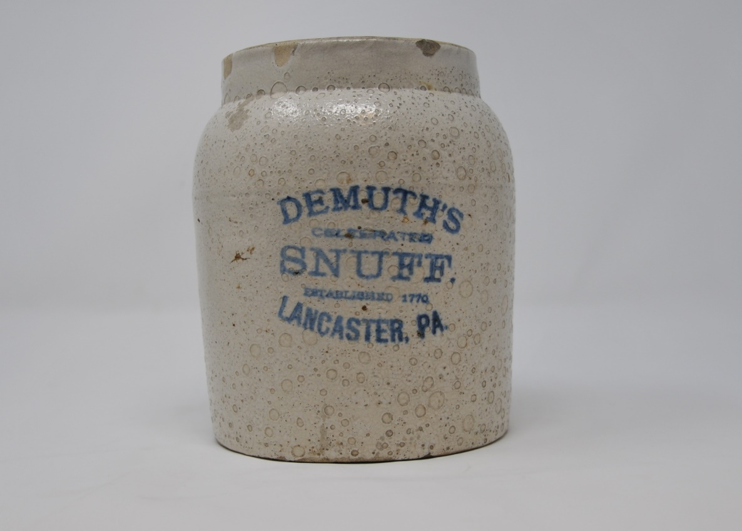

Thrown salt glazed earthenware snuff crock  
Blue stamped lettering on front, "Demuth's Celebrated Snuff / Lancaster / PA"

In the 1830s, tobacco began to take its place as a prominent crop of Lancaster County. By 1859, Lancaster County was responsible for 65% of tobacco production in Pennsylvania. This tobacco production led to an increase in tobacco warehouses, cigar companies, and makers of cigar boxes in the area. Tobacco production has since decreased, with less than 10,000 acres of tobacco planted in Lancaster in the 1990s.

In 1770, Christoph Demuth opened Demuth Tobacco Shop on East King Street. The shop was the oldest continuously operating tobacco shop in America.This small object represents a key crop, a major industry, and a significant aspect of industrialization in Lancaster County.

Questions to Consider

How does this object show different types of craftsmanship from what we see today?

How would this object have played a role in the daily lives of Lancastrians?

How is this sector of the economy unique to Lancaster?

Hubley Airplane Toy

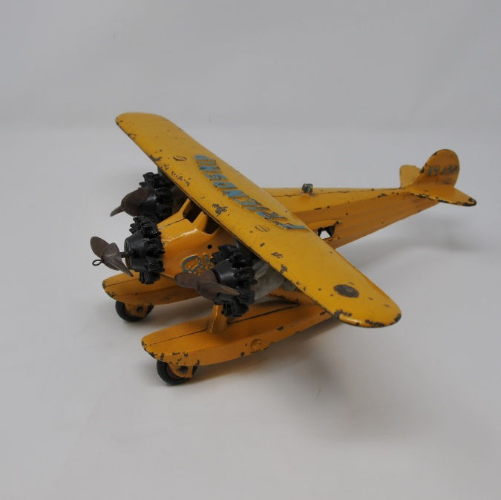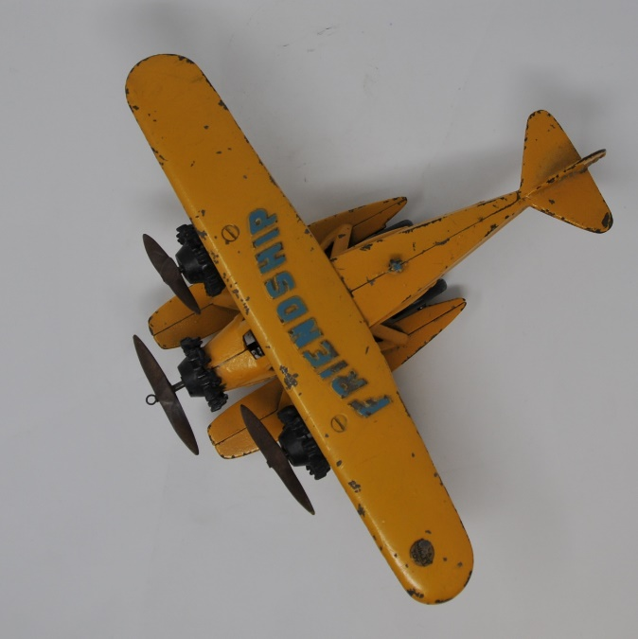

Cast-iron toy tri-motor Fokker aquaplane, painted yellow. Made of multiple castings fitted and securred with screws. Three wire spring cables are fitted to pulleys under plane, allowing the 4 rubber wheels to turn the 3 propellers and activate a noisemaker. Raised letters atop wings spell "FRIENDSHIP". "NX4202" is on tail and "Fokker" is on left side of fuselage. All letters painted blue. Inside hollow fuselage is "HUBLEY." Gold seal on left end of wing reads "It's a Hubley Toy". Profile of Earhart is cast into one of the two rear windows on left side.

The Friendship was flown across the Atlantic from Newfoundland to Wales, on June 17, 1928, with Amelia Earhart aboard. She was only a passenger, but this event won her immense fame, including a ticker tape parade in New York City, and started her career as a major celebrity. (see Notes on why this plane was made.)

The Hubley Manufacturing Company was based out of Lancaster, Pennsylvania. Their primary products were toys and decorated repeating cap guns, rifles, and holsters. The first miniature toys were made of cast iron; later, plastic became the prominent material. In its earlier years, the company made a line of “metal art goods,” which included lamps, tables, bookends, doorstops and knockers.

Questions to Consider

How does this aspect of the economy differ from the others you’ve looked at so far?

How might supply shortage have impacted this company in the early 20th century?

**Criminalization of Unionization (1877)**

Indictment of Edward N. Seals – Aiding a Strike on a Railroad

“…with force and arms, willfully, maliciously, and unlawfully in aid and furtherance of the objects of a strike upon the Pennsylvania Railroad in said County, did interfere with, molest and obstruct a locomotive engineer and other railroad employees engaged in the discharge and performance of their duty as such, to the evil example of all others in the like case offensive.”

Questions to Consider

What can you deduce about the working conditions experienced by railroad workers?

How does this fit into the greater theme of industrialization? Unionization?

What are some of the challenges that can come with using and understanding primary source resources?

August Sessions 1877

Committ. 66/99Aug. no. Edward N. Seals } Aiding a Strike on a Rail Road

Indictment

True Bill

Geo. Byrod foreman

Dec. 11th 1877 – Defendant pleads “Not Guilty”

Not guilty

County for costs

Of August Sessions, 1877

Lancaster County, ss.

The Grand Inquest of the Commonwealth of Pennsylvania, enquiring for the County of Lancaster, upon their oaths and affirmations, respectively Do Present That Edward N. Seals, late of the County aforesaid, Yeoman on the twenty-sixth day of July in the year of our Lord One Thousand Eight Hundred and Seventy-seven at the County aforesaid, and within the jurisdiction of this Court, with force and arms, willfully, maliciously, and unlawfully in aid and furtherance of the objects of a strike upon the Pennsylvania Railroad in said County, did interfere with, molest and obstruct a locomotive engineer and other railroad employees engaged in the discharge and performance of their duty as such, to the evil example of all others in the like case offensive. Contrary to the form of the Act of the General Assembly, in such case made and providence, and against the peace and dignity of the Commonwealth of Pennsylvania.

And the Inquest aforesaid, upon their oaths and affirmations aforesaid, do further present that the said Edward N. Seals, afterwards, to wit, on the day and year aforesaid, at the County aforesaid, in aid and furtherance of the objects of a strike, upon the Pennsylvania Rail Road, in said County, did obstruct the track of said Pennsylvania Rail Road and injure and destroy certain engines, cars, and other rolling stock and other property of the Pennsylvania Rail Road Company and did take possession of and remove such property, and did prevent and attempt to prevent the use thereof by said the Pennsylvania Rail Road Company and its employees, to the evil example of all others in the like case offending.

Contrary to the form of the Act of the General Assembly in such case made and provided, and against the peace and dignity of the Commonwealth of Pennsylvania.

Witnesses for Commonwealth

John Rowe

Sam E Evans

Jno. Weiterman

B. Van Lew

Andrew Baker

James Dailey

Thomas Connel

Wm. Baker

W.W. Upp Frank Spotten

J. W. Johnson

District Attorney

For aiding a strike on a Railroad

Not guilty, county for costs

Geo Young, Jr.

Thomas Bechard

Henry Marsh

John B. Mylin

Frank Hegener

P.B. [Vache]

John H. Miller

E.R. Girvin

E.M. Rhoads

Samuel Harbison

A.T. McClellan

B.F. Taylor

Watt & Shand Print Block

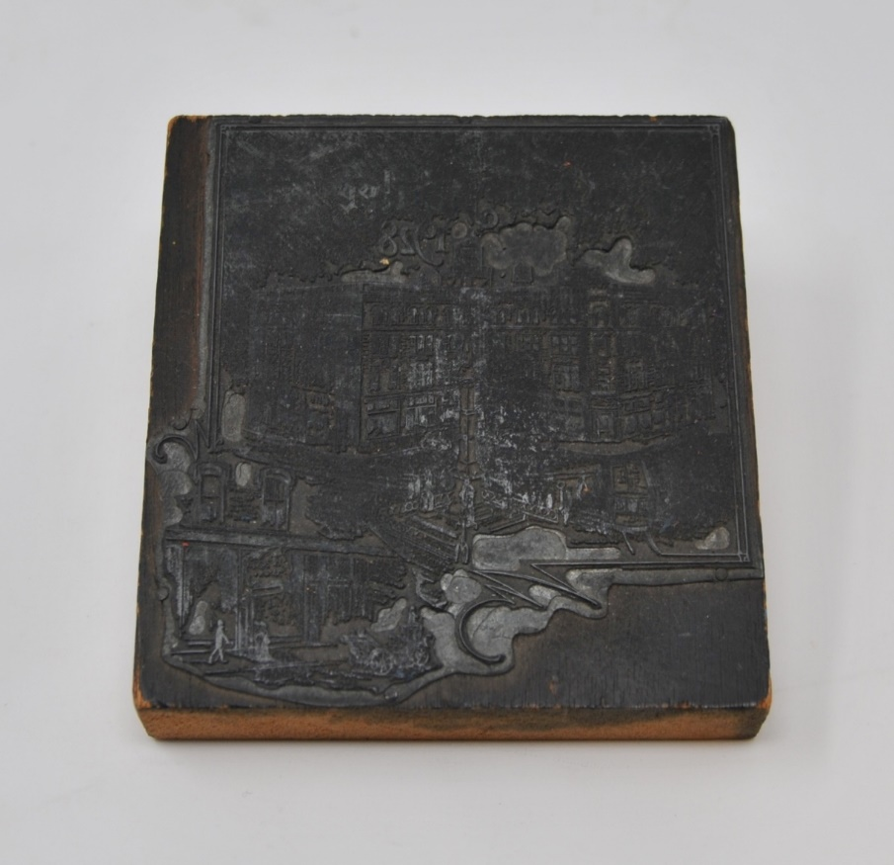

Wooden printing block showing Watt & Shand department store facade with Soldiers & Sailors monument in Center Square Lancaster city. Golden Jubilee 1928 inset on viewer's lower left shows doorway and sidewalk. Entire image is surrounded by 2 parallel lines as a border with flourishes around inset. pink or salmon paper stuck to back.

On 9 March 1878, Peter Watt, James Shand and Gilbert Thompson opened a new store, The New York Store, featuring new lines of foreign and domestic dry goods as well as fancy goods and notions. After the death of Thompson, Watt and Shand purchased a building located at 8-10 East King Street and changed their name from The New York Store to Watt, Shand and Company. Then during 1885, the store name was shortened to Watt & Shand even though the business was expanding to acquire 6 East King Street. The owners proceeded to expand the business over several decades and procured other stores during the 1950s and 1960s. The branch store opened in 1970 at Park City Mall. The Bon-Ton Stores purchased Watt & Shand in 1992 and the store officially closed in March of 1995.

Questions to Consider

How does this object represent different advertising techniques?

How does the legacy of the Watt & Shand still impact Lancaster City?

**The View over Chickies Rock**

The Low Grade Railroad

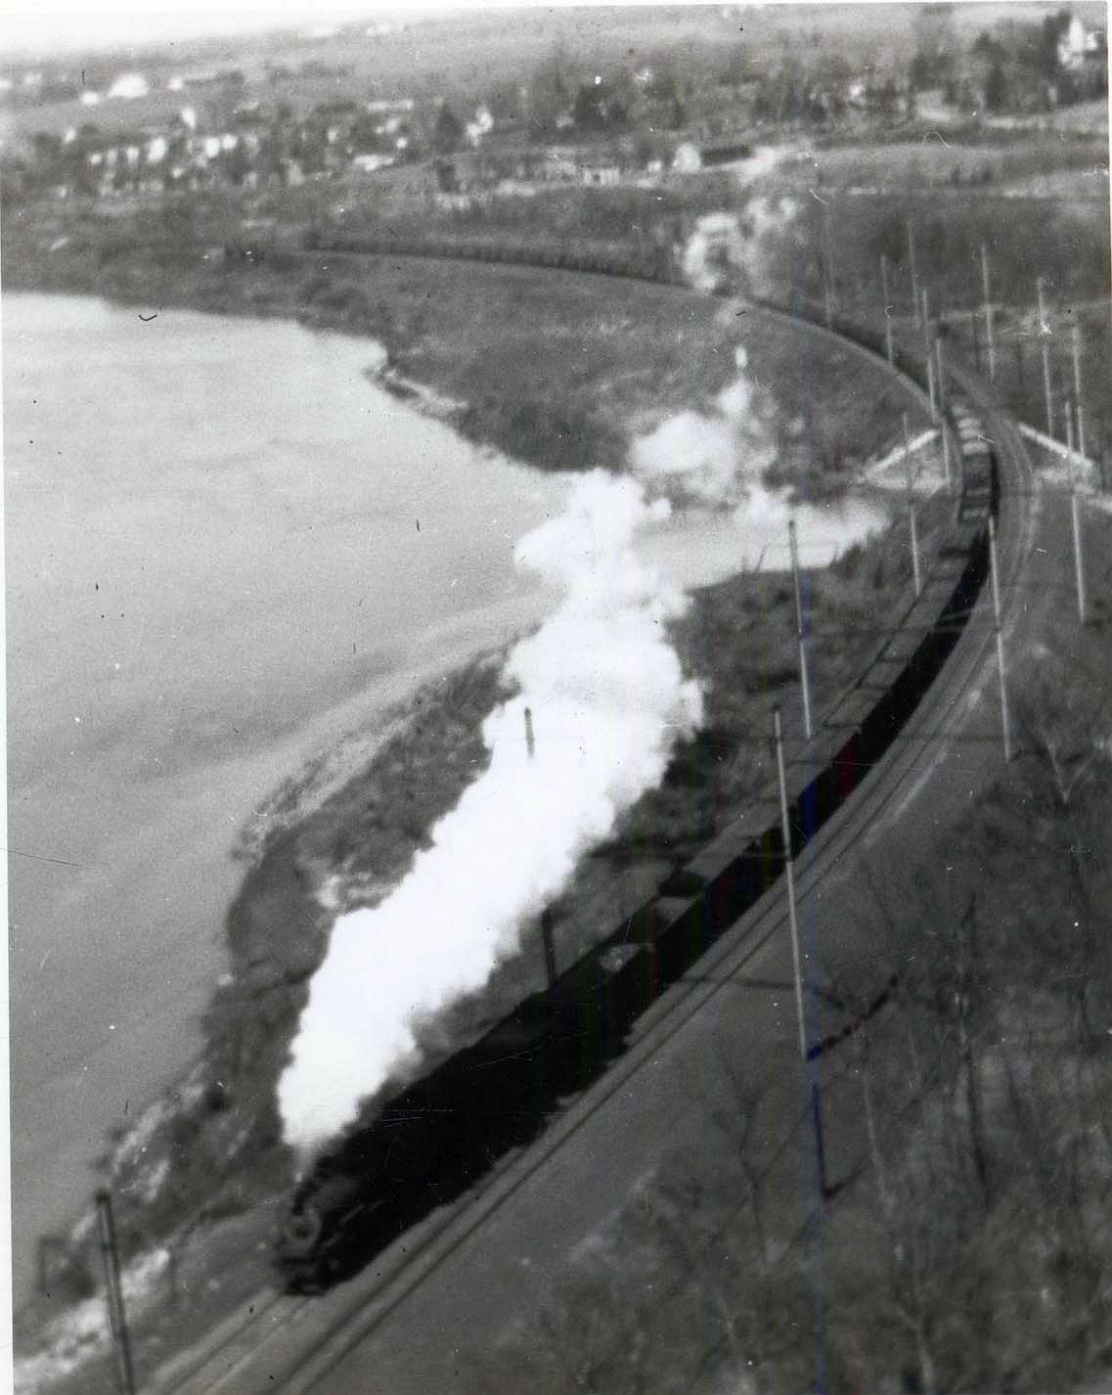

From the vantage point of the top of Chickies Rock, a steam powered freight is caught headed southward over the "Low Grade". The lower end of Marietta is in the distance. Courtesy John D. Kendig, Manheim, Pa. This photograph is part of the John D. Denney, Jr. Photograph Collection.

Questions to Consider

How did the railroad impact daily life?

How did it impact business and industry?

Why would someone have photographed a freight train?