**Lancaster as a Home Front**

The Impact of the World Wars

Contents

* World War I Posters
* The Noncombatant Experience
  + Application for farm furlough (1918)
* Camp Dix medical card (1919)
* Welcome Home Parade (1919)
* Letters from Home (1943)
  + From the Pvt. George L. Caley Collection
* Eleanor Flora at work (1943)
* Playground War Bond Stand (1944)
* Lt. Gen. Daniel B. Strickler

Questions to Consider

* How did Lancaster County contribute to the war effort?
* How did Lancaster County experience the world wars?
* How did different religious groups experience this period?
* How might the Lancaster experience differ from that of other parts of the country?

World War I PostersWorld War One Poster
depicts fresh produce, hanging and in a basket
reads "Eat less / and let us be thankful that we have enough to share with those who fight for freedom / United States Food Administration" World War One Poster
depicts war official sending off a young soldier, explosions in the background
poster reads "SEE HIM THROUGH / HELP US TO / HELP THE BOYS / National Catholic War Council / Knights of Columbus / United War Work Capaign - Week of November 11 - 1918"

World War I poster with Rd cross nurse helping young children holding small French flags
mother in foreground holding a baby up to the nurse
poster reads "MOTHERLESS / FATHERLESS / STARVING / HOW MUCH / to save these little lives? / War Fund Week / One Hundred Million Dollars / May 20th - 27th"

Questions to Consider

What do these posters tell us about the war effort? What were the needs of the army at this time?

What were other goals of the people making these posters? What did they hope to accomplish?

Look at the organizations sponsoring these posters. Do any of them surprise you? Why or why not?

**The Noncombatant Experience**

Application for farm furlough (1918)

While many men left their jobs behind to fight overseas, some were needed to stay behind and operate various jobs, including farming.

Many members of historic peace churches, who were religiously and morally opposed to fighting, used farm furloughs as a way out of the war effort, while others resisted to a greater degree, facing imprisonment.

a noteworthy side-note:

Pacifists in Chains by Duane Stoltzfus is a great resource to learn more about this topic

Application for Furlough

Form 1035, P. M. G. O.

I.

(Place)

(Date)

I, _ hereby make application for the furlough of the soldier named below from _, 1918, to _, 1918, to enable him to engage in agriculture.

(Relation to registrant)

II.

Statement of facts, to be made by the person making the apploication.

1. Name of soldier for whom application is made _
2. Rank _ Organization_ Present Station _
3. Location of farm on which soldier is desired for work _
4. Name of owner or tenant of farm _
5. Kind of farm _
6. Number of persons normally engaged on farm _
7. Number of males above age fourteen now working on farm _
8. Acreage of farm _ Acreage under cultivation _
9. Crops to be grown this year and approximate acreage of each )
10. Number of horses on farm _; cattle _; hogs_; sheep_
11. Market value of (a) farm_

(b) last year’s production _

(c) this year’s anticipated production _

(d) farm machinery_

12. What is soldier’s experience in farming?_

13. What wages are paid farm labor in vicinity?_

14. Is farm labor reasonably available in vicinity? _

AFFIDAVIT

(City.) (State.)

I swear (or affirm) that all answers to questions 1 to 14 in the foregoing statement of facts are true; that the soldier for whom furlough is requested is urgently needed for the time asked; that he can not be replaced without substantial and material loss to the products of the farm; and that his furlough is desired for the sole purpose of enabling him to work on the farm.

(Applicant)

Sworn to and subscribed before me this _ day of _, 19_

Note. – Affidavit may be sworn to before notary public, clerk or member of a local or district board, Government appeal agent, Judge Advocate or postmaster.

III.

Recommendation and Finding of Local Board

[ Stamp of Local Board.]

The above-named local board finds that the services of the soldier herein named are urgently needed on the farm herein described; that the said farm produces substantially more agricultural produce than is consumed by those working on the place; that the soldier can not without great difficulty be replaced thereon; that his continued absence is reasonably likely to decrease the production of the farm under that which it can reasobably be expected to produce if the soldier is returned; and that the registrant will be of value as a farm laborer.

Remarks: _

Note. – If the local board does not find or recommend in accordance with the above form, it will ender under the head of Remarks its reasons for adverse findings or recommendations.

It is therefore recommended that this furlough to be {granted / refused} from _ to _ Place: _ Date_

(Member or clerk of Local Board.)

IV.

(Place.)

(Date.)

I {concur in / dissent from} the above finding and recommendation.

(County agent or Government appeal agent._

V.

Engagement of soldier

I join in the above application, and if the furlough here asked for is granted I hereby engage to utilize the time of my absence solely and completely in farming, to work earnestly and well, and that if for any reason my services cease to be urgently needed before the expiration of my furlough, to report immediately for military duty at my proper post.

(Signature.)

(Rank.) (Organization)

Place: _ Date: _

VI.

(Military station.)

(Date.)

The application for furlough contained herein {approved. / disapproved.

(If disapproved, state reason) _

(Commanding.)

Questions to Consider

How do you think most Americans felt about these pacifists refusing to fight?

Why would they have been imprisoned? How should the government have handled this?

Why would some comply with the process and apply for furloughs?

Camp Dix Medical Card (1919)

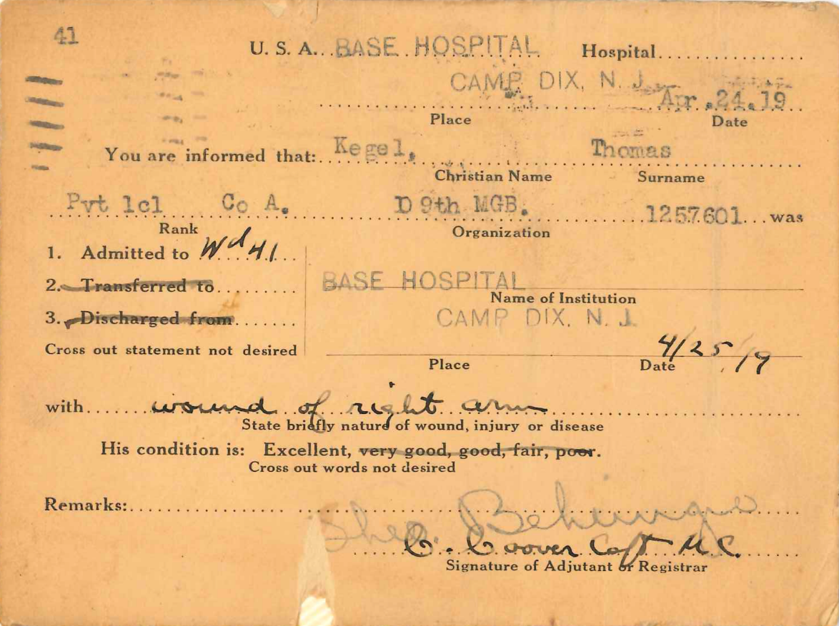

Thomas Kegel (1895-1958), James Kegel (1891-1927), Victor Kegel (1898-1923) were three brothers who served together in the 109th Machine Gun Battalion during World War I. Their parents were Charles and Mary Rogers Kegel, and they had eleven children. Their family home was on 59 Locust Street in Lancaster, Pennsylvania. They were all drafted in 1917, and were trained in Camp Hancock in Augusta, Georgia. After their extensive training, they were sent to fight in the trenches in France. On separate occasions, each brother was wounded during the war, but they all survived and came home to Lancaster after the war in 1919.

Questions to Consider

How do you think Kegel’s family felt when they heard he was at Camp Dix?

Consider the timeline of World War I. How do you think Kegel felt being transferred to Camp Dix at this time?

Welcome Home Parade (1919)

Lancaster city street parade, with rows of soldiers marching
rowhomes in the background
young child in the foreground

This photo was taken in Lancaster City during a “Welcome Home” parade in 1919.

Questions to Consider

What does this tell you about how Americans perceived the end of the war?

How did most Americans feel about the soldiers returning home?

**Letter from Home (1943)**

From the Pvt. George L. Caley Collection

“Did you know Pat Bard? He was on the Ice truck for some years. Well he is in the thick of the fighting (or was, the fighting is now over) in Sicily. What a time our boys are having over there. Those who like to talk (what a chance for you), will sure have something to talk of when they get home."

Questions to Consider

What does this letter tell us about the Home Front experience?

How were the people of Lancaster impacted by the demands of war?

**Letter from Home**

From the Pvt. George L. Caley Collection

Columbia, Pa. Aug. 21, 1943

Dear George,

Guess what? The boys dormitory at MSTC. is to be used to house 150 females who have no lodging place in Lanc. They have been brought in to Lanc. to work in the munitions dept. at Arms-strongs and are to be lodged in the boys dorm at your college. How is Dick going to like that, I wonder?

The paper states that they are to have certain campus and gym facilities also. They said that there is plenty of room elsewhere in the buildings to lodge the few males who stay there. College opens Sept. 15.

Joe and Ralph have gone to the movies to see Abbott + Costello in “Hit the Ice.” That gives me a free evening to write letters. I’ve already done one to a boy in Texas and one to a boy in N. Africa somewhere. After yours, I have four more to do. Wonder if I’ll hold out that long.

Did you know Pat Bard? He was on the Ice truck for some years. Well he is in the thick of the fighting (or was, the fighting is now over) in Sicily. What a time our boys are having over there. Those who like to talk (what a chance for you), will sure have something to talk of when they get home.

Wonder if I’ll know any of them well enough to have them tell me all about the places and people they see. I love to hear all about such things. Tony Bernards, Blossom’s brother-in-law, sent me some swell views from Texas. That boy Dick would not send us any cards from anywhere he was stationed. Via postcard views is our way of seeing the U.S.A. Blossom has one brother-in-law in Texas, one in S. Carolina, one in Fla., one in n. Africa, and one who just went in last month, and I don’t yet know where he is.

We had one awful chilly week, but it is warmer this evening. I believe it is getting ready for rain tomorrow. Dick is coming home from camp tomorrow, and I’ve got a big hunk of ham baked for him. Well I must stop or I won’t get them nearly all done this evening.

Write when you can find time.

Sincerely –

Biddy.

Mrs. J. Lockard

[envelope front]

Pvt. George L. Cale

Casual Mess Detachment

C.R.T.C.

Ft. Riley,

Kansas.

[envelope back]

From – Mrs. J. Lockrad

275 S. 8th St.

Columbia, Pa.

Eleanor Flora at Work (1943)

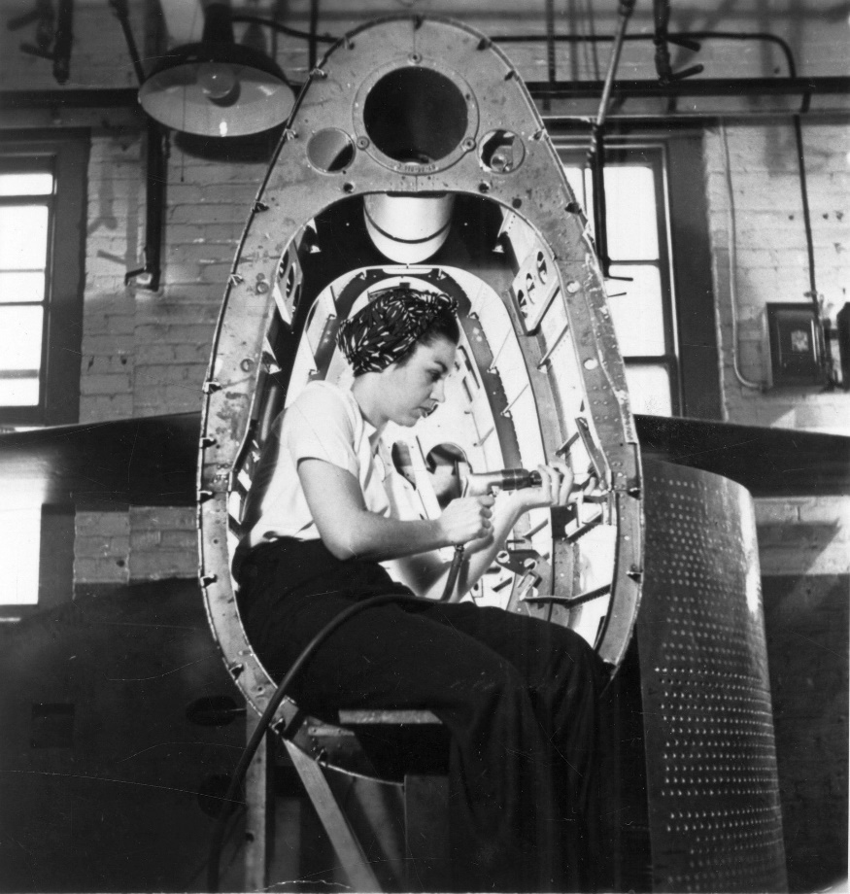

“Rosie the Riveters” like Eleanor Flora helped in the war effort in Armstrong’s Floor Plant during World War II. Taken in 1943, when 19 years old, the photo was used as an employment advertisement for the company. Eleanor enlisted in the Navy as a W.A.V.E. – Women Accepted for Volunteer Emergency Service.

Questions to Consider

How does Eleanor Flora’s story reflect the wartime experience for women?

How does this challenge preexisting gender roles?

How does this time set the stage for change to come?

Playground War Bonds Stand (1944)

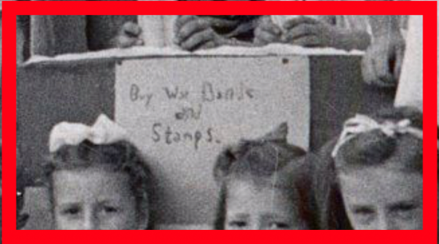Group of children at an outdoor stand
sign on the front of stand reads "Buy War Bonds / and / Stamps."


This was taken on July 25, 1944 at Edward Hand playground in Lancaster City, and shows young children selling War Bonds and Stamps through a stand similar to a lemonade stand.

Questions to Consider

What does this tell you about how the war was perceived?

How much did the war and war effort become a part of daily life?

Could you imagine seeing something like this today? Why or why not?

Lt. Gen. Daniel B. Strickler

Portrait of Lt. Gen. Daniel B. Strickler in uniform
painting is in a gold frame
Lt. Gen. Strickler has short, dark brown hair and a pale complexion
in WWII army green uniform jacket, two stars on his epaulette pieces
red keystone patch on the shoulder

Lt. Gen. Daniel B. Strickler enlisted in the National Guard out of high school, fighting in the 1916 Mexican-birder conflict, and served in World War I. He became a captain at age 21.

After attending Cornell University, he established a law practice in Lancaster. He won election to state legislature in the early 1930s and served as Lancaster’s police commissioner in 1932.

When the United States entered World War II, Gen. Strickler, then a colonel in the Army Reserve, went on active duty and accepted a reduction in rank. He fought with the 28th division through France and Belgium. He later fought in the Korean War and continued serving in Rome and Tokyo through the 1950s. He retired from the Army in 1957 as a three-star general.

Questions to Consider

How does Lt. Gen. Strickler’s story fit into the greater story of the 20th century?

How does he exemplify ideals of patriotism and service at this time?