The Pennsylvania Presidency
The Efforts and Effects of the Buchanan Administration
Contents
- “James Buchanan as a Lawyer”
  - W.U. Hensel’s address at the University of Pennsylvania
- Ceremonial Japanese porcelain bowl
  - Gift of State under President Buchanan from Japanese delegation
- Wheatland
  - James Buchanan’s Lancaster mansion
- From the first First Lady
  - Harriet Lane Johnston’s dress
- Campaign Ribbon
  - The 1856 Campaign
- James Buchanan’s Inaugural Address
- The Constitution in Hand and at Mind
  - McMaster’s painting of Buchanan
- James Buchanan, the Conservatives’ Choice 1856: A Political Portrait
  - Philip G. Auchampaugh, University of Nevada
- His Lasting Legacy
  - Buchanan’s Statue
- James Buchanan Film
  - A Documentary by LancasterHistory

Questions to Consider
- How did Buchanan’s early career prepare him for public office?
- What were some of the central points of Buchanan’s policy?
- How is Buchanan remembered? Is this accurate?

“James Buchanan as a Lawyer”
W.U. Hensel’s address at the University of Pennsylvania

“When he became a legislator, having been elected to Congress in 1820, he had opportunity to reveal the character and to exercise the qualities of a constitutional lawyer.”

Questions to Consider

Do you notice any bias in the author’s writing? If so, how do you think Hensel personally feels about Buchanan?

How did Buchanan’s law career prepare him for public office?

How can you try to filter out bias from sources? Why is it important to acknowledge?

Ceremonial Japanese porcelain bowl
Gift of State under President Buchanan from Japanese delegation
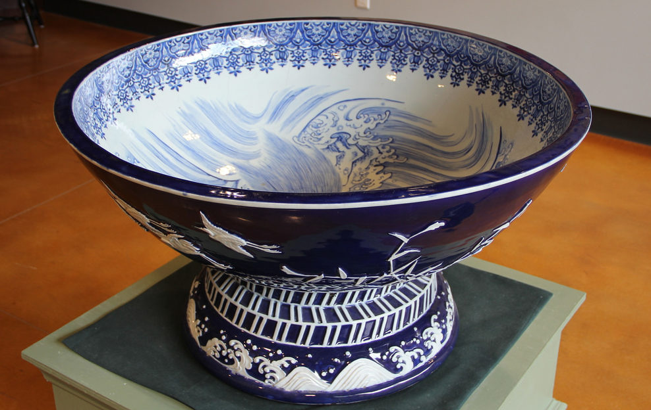
Extremely large Japanese porcelain bowl. White ground with blue decoration. Footed with sea waves on base and three rows of slanted lines on neck of base. Outside of bowl has cranes and bamboo depicted in white with blue ground color. Inside shows sea scene.

This bowl was presented as a gift of state to President Buchanan in 1860 by the Japanese delegates representing the Tokugawa shogunate government. The bowl was created by Jihei Kawamoto as one of two bowls for sake. It reflects the Emperor’s personal symbol and his deep regard for James Buchanan marking a new and firm friendship between Japan and the United States.

Questions to Consider
How did Buchanan’s diplomatic career impact his presidency?
Wheatland
James Buchanan’s Lancaster mansion
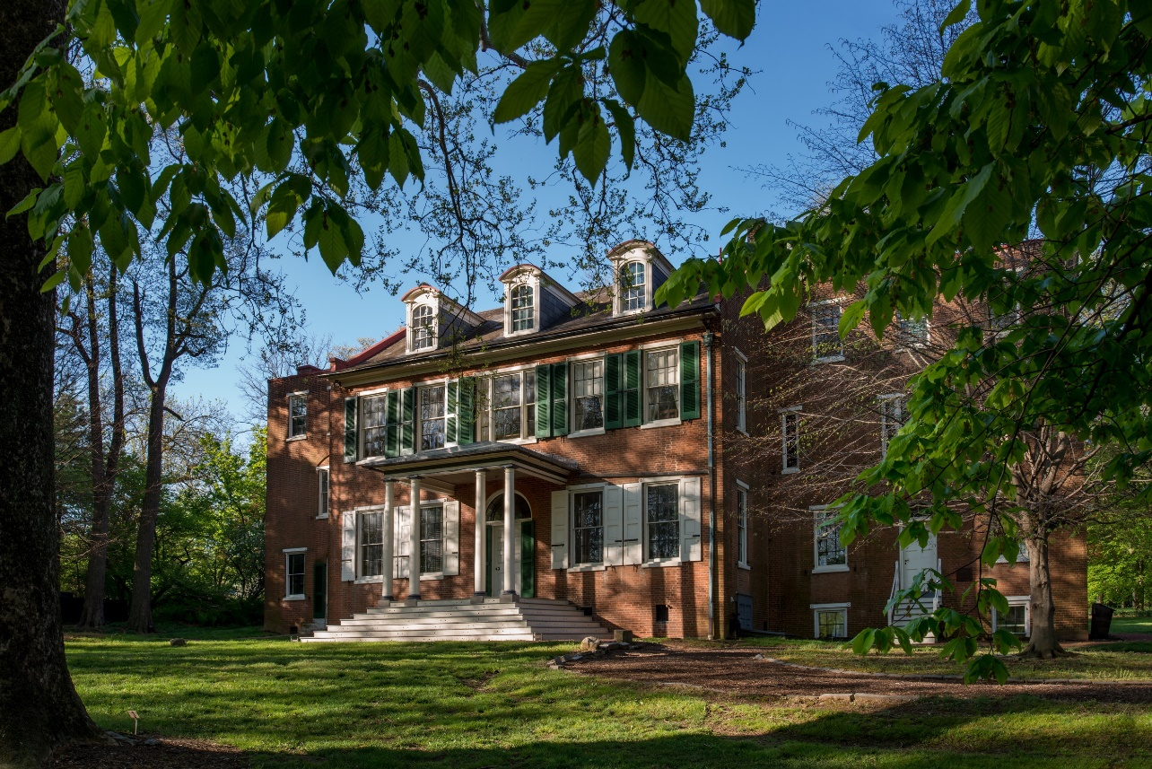

The home on the Wheatland property was originally built in 1828. In 1848, James Buchanan purchased the property for $6,750. In the spring of 1849, he and his “little family” moved in, including his niece, Harriet Lane Johnston, his nephew James Buchanan “Buck” Henry, and housekeeper Esther “Hetty” Parker.

Located on the southeast side of the lawn behind the mansion is a two-room brick privy. On the southwest side of the lawn is a two-story brick smokehouse and icehouse structure.

Although Wheatland was an ornamental farm, it was complete with barns, livestock, wheat fields, a fruit orchard, graperies, and a garden.

Questions to Consider
Why should we preserve historic houses?

What can we learn from these sites?

From the first First Lady
Harriet Lane Johnston’s Dress

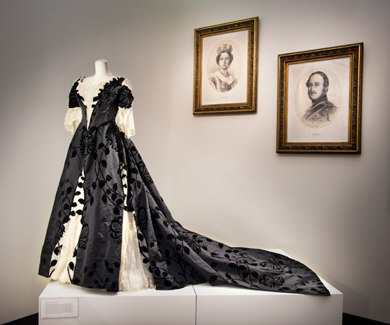

Sheer lace overdress. White lace with white embroidered flowers. Bodice has short cap sleeves. Around neckline is a slightly gathered 5in wide band of ecru or light tan lace. A .5in wide white lace band stands up from neck. Pink ribbon flowers and green embroidered leaves are stitched around neckline. Back closure with hooks and eyes at neckline and waist. Open placket from waist is 15.5in long.

James Buchanan, her uncle, took her in when she was only 11 years old. As a child, she was described as strong-willed, bright, and active. Her uncle encouraged her intellectual development, enrolling her in a number of elite schools. Harriet became Buchanan’s hostess, both in London and later at the White House. Many journalists referred to Harriet as the Fair First Lady of the land, bringing the title “First Lady” into popularity.
Harriet later married Henry E. Johnston on January 11, 1866. After the death of their two sons followed by her husband, she devoted her time to establishing and maintaining a children’s hospital, preserving the memory of her uncle, supporting the arts, and traveling. During her time in the spotlight, Harriet was seen as an ideal image of fashion, womanhood, and class, and her style was mirrored by women around the world.

Questions to Consider
How did Harriet Lane exemplify the ideal of womanhood at this time?

How did she challenge ideas of femininity? How did she conform to and perpetuate them?

How is her role different from that of other First Ladies in this period?

Campaign Ribbon
The 1856 Campaign
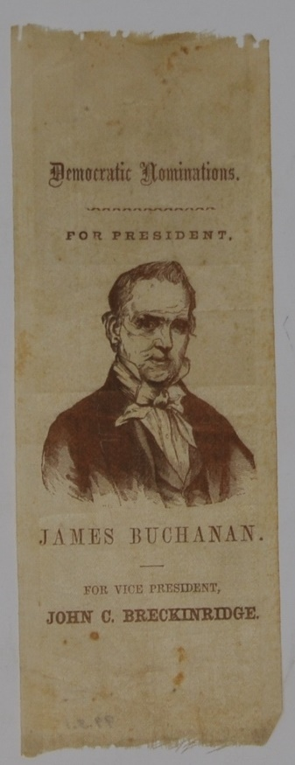
James Buchanan and John C. Breckinridge comprised the Democratic ticket for the presidential election of 1856. Buchanan faced two-opposing parties; the Republicans, represented by John C. Fremont and the American or Know-Nothing party, represented by Millard Fillmore. The main issue over the course of the election was the question of slavery in the territories. Buchanan and the Democratic Party ran on a states-rights platform. They supported non-intervention with slavery in the states and territories, instead leaving it up to the people if they wanted to allow slavery. Largely due to the support of Southern states, Buchanan won the election and became the 15th president of the United States.

Questions to Consider

How did Buchanan’s campaign set the course for his policy in office?

James Buchanan’s Inaugural Address

“Without entering into the argument, I desire to state, at the commencement of my administration, that long experience and observation have convinced me that a strict construction of the powers of the Government is the only true, as well as the only safe, theory of the Constitution. Whenever, in our past history, doubtful powers have been exercised by Congress, these have never failed to produce injurious and unhappy consequences.”

Questions to Consider
What promises does Buchanan make?

What is his stance, according to his address, on the issue of slavery? On foreign relations and trade?

How does he express his interpretation of the Constitution?

The Constitution in Hand and at Mind
McMaster’s portrait of Buchanan
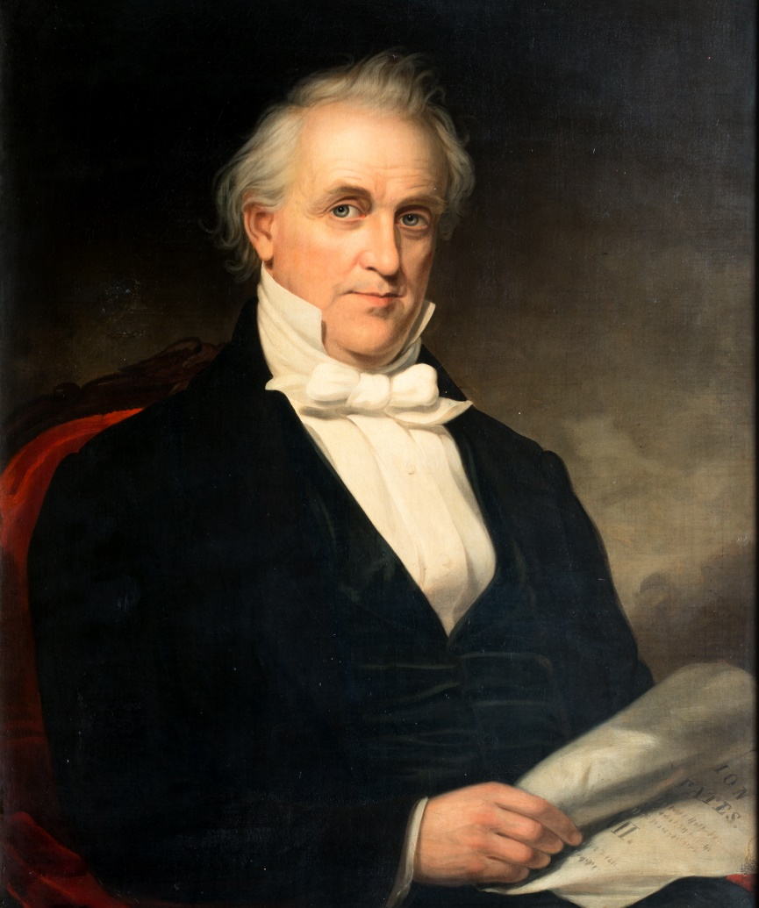

James Buchanan shown from waist up, sitting in red upholstered chair. Wearing black suit, white shirt and white bow tie, high collar. Eyes looking right and body turned to left. Right hands holds document-may be the Constitution.

William McMaster painted this portrait from life at Wheatland in July of 1856. It hung in the artist’s home as part of a series of famous Americans. After McMaster’s death, it was passed down in the Buchanan family until it was given to the James Buchanan Foundation in 1945.

a noteworthy side-note
In portraits, the objects held by the subjects are often carefully chosen to make a statement about the individual.

Questions to Consider
Why would Buchanan have chosen to be painted holding the Constitution?

What does this say about his political choices and policy?

James Buchanan, The Conservatives’ Choice 1856
A Political Portrait
Philip G. Auchampaugh, University of Nevada

“When he became a legislator, having been elected to Congress in 1820, he had opportunity to reveal the character and to exercise the qualities of a constitutional lawyer.”

Questions to Consider
Do you notice any bias in the author’s writing? If so, how do you think Hensel personally feels about Buchanan?

How did Buchanan practice law?

How did Buchanan’s law career prepare him for public office?

How can you try to filter out bias from sources? Why is it important to acknowledge?

His Lasting Legacy
Buchanan’s Statue
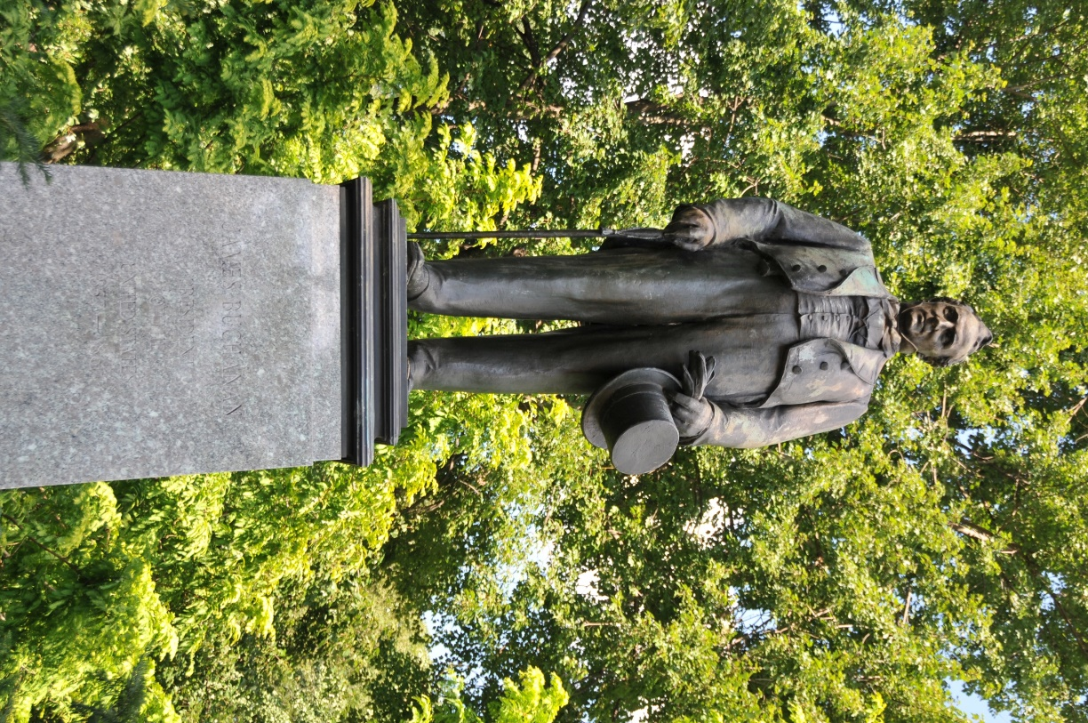
This statue of James Buchanan is located at the entrance to Buchanan Park on Buchanan Avenue. Base of the statue reads “James Buchanan/ President of the United States/ 1857-1861” and below “Given in Memory by Dulon F. Buchmiller.”

Questions to Consider
How is Buchanan remembered as a president?

What is the significance of memorialization through statues?

James Buchanan Documentary Worksheet

- Why was Buchanan considered to be so prepared for the presidency?

- How did Buchanan approach foreign affairs, before and during his administration?

- What were some of the most divisive issues faced by the Buchanan administration?

- How did Buchanan approach the debate surrounding slavery?

- Do you agree or disagree with the claim that Buchanan was responsible for the Civil War? Why?

