**The Struggle Against Slavery**

The Local Perspective on a National Divide

Contents

* Gradual Abolition Timeline
  + A Digital Secondary Source
* Runaway Slave Handbill
* Slave Owners Book
  + Record of Slave Owners in Lancaster County as of 1790
* The Underground Railroad: A Record by William Still
  + William Whipper’s role
* The Christiana Riot
* Habeas Corpus papers
  + Charge for kidnapping a free black man
* A Stop on the Way
  + Thaddeus Stevens’ Home
* Abolition Divides the Meeting House: Quakers and Slavery in Early Lancaster County
  + Journal of the Lancaster County Historical Society
* Stitching together a Divided Nation
  + Quilt with Abolitionist Imagery

Questions to Consider

* How would you compare the process of abolition in Pennsylvania to that of the rest of the states?
* How does religious background and theology play into the abolition movement?
* How can we make connections between these stories and objects to create a more holistic view of the abolition movement in Lancaster County?
* How should historians take steps to tell these stories?

**Gradual Abolition Timeline**

Questions to Consider

How did the process of Gradual Abolition distinguish Pennsylvania from other states?

What feelings does the poem by Harriet Beecher Stowe evoke?

Runaway Slave Handbill

Runaway Slave Handbill, reads "200 Dolls. / REWARD! / Runaway from the Subscriber, on / Tuesday Morning last, 4th June, / Two negro Men: / One of them named WILSON, - he is about 23 years old, 5 feet 9 or 10 inches high, dark complexion, nearly black, tall and straight, tolerably stout built, bushy hair, clothing not re-collected. / JOHN (brother to Wilson) is about 21 or 22 years old, about 5 feet 8 inches high, not quite so dark as Wilson. He had on when he went away, a pair of thick white cotton duck trowers and drab roundabout. / The above reward will be paid if arrested and secured out of this State or the District of Columbia, and 50 dollars for each of them if arrested and secured in this State. / DAVID M. BROGDEN, / Near Davidsville, A. A. County; Md. / Baltimore, 6th May, 1844 / Printed by LUCAS & DEAVER, Calvery street, (second door from Lovely Lane,) - Baltimore."
in a black frame 

A handbill requesting the return of two runaway slaves, advertising a reward. This was issued by David M. Brogden out of Baltimore, MD in 1844. This was printed before the Fugitive Slave Act, so it was based out of capital interest, not legislation at the time.

Questions to Consider

Why would this have been advertised in the Lancaster County/ Central Pennsylvania area?

Imagine being someone who was formerly enslaved living in Pennsylvania. What would it be like to see posters and handbills like this?

Slave Owners Book

Are you surprised by the number of slaves and slave owners in Lancaster County? Why or why not?

Which township(s) had the most slaves? Why might some townships have had significantly more slaves than others?

**The Underground Railroad**  
A Letter from William Whipper to Still

“Now the slaves are emancipated, and we are all enfranchised, after struggling for existence, freedom, and manhood – I feel thankful for having had the glorious privilege of laboring with others for the redemption of my race from oppression and thraldom; and I would prefer to-day to be penniless in the streets, rather than to have withheld a single hour’s labor or a dollar from the sacred cause of liberty, justice, and humanity.”

-William Whipper

Questions to Consider

How did William Whipper contribute directly to the cause of emancipation?

How did things change after the passing of the Fugitive Slave Act in 1850?

The Christiana Resistance (1896)

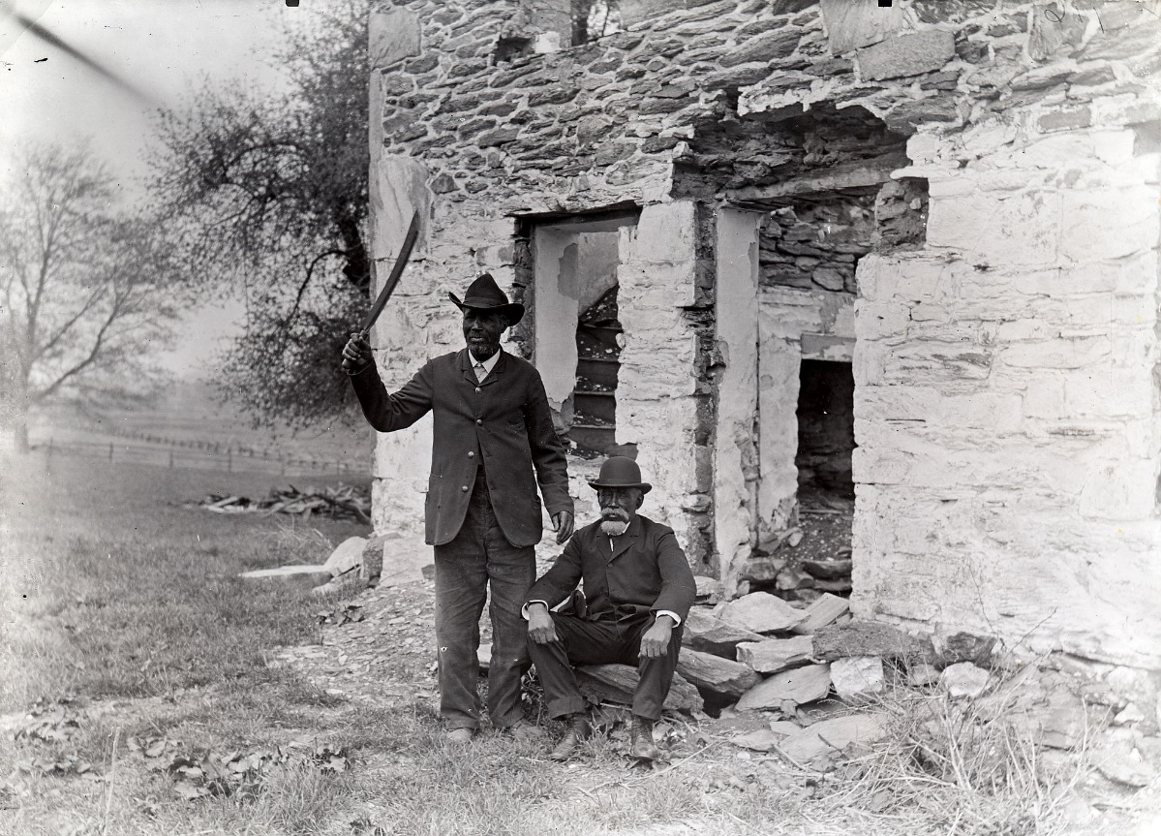

Peter Woods, left, and Samuel Hopkins pose with the corn knife used in the Christiana Resistance in front of the ruins of the home of William Parker.

The Fugitive Slave Act of 1850 required that all captured runaway slaves be returned to their owners and that those aiding runaways suffer the full legal consequences of their actions. On September 11, 1851, William parker, a freedman living near Christiana, chose to oppose this law when Maryland slave owner Edward Gorsuch and a posse of supporters arrived to claim his property. The skirmish ensued left Gorsuch dead, his son wounded and William Parker and several others charged with treason. Parker and his family sought freedom in Canada. The Christiana Resistance was a spark in the mounting tension between North and South.

Questions to Consider

How did the Fugitive Slave Act contribute to rising tensions?

How does this photo portray the survivors of the resistance?

Habeas Corpus Papers

“These are to command you the said Const. forthwith to convent and deliver into the Custody of the said Keeper of the said Common Jail: the Body of Gillmore Hull charged before Sam Slokum, a Justice of the Peace in and for the said County with Kidnapping a free colored man in said County. And you the said Keeper are hereby required to receive the Gillmore Hull into your custody in the said Common Jail, and him there safely Keep until carefully discharged & c.”

a noteworthy side-note: & c can be read as “etc.”

Questions to Consider

What can we learn about how free people of color were viewed at this time?

What are some of the challenges that come with analyzing primary sources?

Habeas Corpus Papers

1860 March 15th. Gillmor Hull discharged from custody on giving surety for his appearance at this next Court of Quarter Sessions of the Peace of Lancaster County. (See Recognizance filed in the office of the Clerk of the said court) to answer & c

H. G. Long

1047) 1860

Commonwealth of Penna. Habeas Corpus for the body of Gilmer Hull

vs.

Jay Cadwell Esq.

Keeper of Lanc. Co Prison

By act of 1785

Livingston

The Commonwealth of Pennsylvania TO Jay Cadwell Esq. Keeper of Lanc. Co Prison

GREETING: YOU are hereby commanded that the Body of Gilmer Hull under your custody detained, as it is said, together with the day and cause of his being taken and detained, by whatsoever name the said Gilmer Hull shall be charged in the same, you have under safe and secure conduct before the Honorable H.G. Long at his chamber at 2 OClock this afternoon March 15 1860 to do and receive all those things which the said Judge shall then and there consider of in this particular.

WITNESS the Honorable H.G. Long Esquire, President of the Court of Common Pleas of said county, at the city of Lancaster, the fifteenth day of March in the year of our Lord, one thousand, eight hundred and sixty.

ALLOWED BY

G. Clarkson for prothy

[Fe ] Brinton

To the Honorable H.G. Long, President Judge of the Court of Common Pleas for the County of Lancaster:

JAY CADWELL, the defendant in the within mentioned Writ, for return thereto, respectfully submits to your Honors that the said Gillmore Hull therein named, is confined in the Lancaster County Prison, by virtue of a warrant commitment, whereof the following is a copy, viz:

Lancaster County Ss. The Commonwealth of Pennsylvania to the Const. of the Township of Sadsbury in the County of Lanc. and to the Keeper of the Common Jail of the said Co. Greeting

These are to command you the said Const : forthwith to convent and deliver into the Custody of the said Keeper of the said Common Jail: the Body of Gillmore Hull charged before Sam Slokum, a Justice of the Peace in and for the said County with Kidnapping a free colored man in said County. And you the said Keeper are hereby required to receive the Gillmore Hull into your custody in the said Common Jail, and him there safely Keep until carefully discharged & c.

Witness the said Justice [at] the Township of Sadsbury aforesaid the 4th day of March 1860.

Signed S. Slokum [seal]

Wherefore the said JAY CADWELL has here before your Honor the body of the said Gillmore Hull, together with the said Writ, as therein he is commanded.

Jay Cadwell KEEPER

1047 1860

Petition of Gilmor Hull for Habeas Corpus

Filed March 15. 1860

To the Hon. Henry G. Long, President Judge of the Court of Common Pleas of the County of Lancaster,

The Petition of Gilmor Hull respectfully showeth That your petition is confined un-justly as he believes in the Lancaster County prison, for some criminal or supposed criminal matter, as appears by a copy of the warrant of the Commitment hereto annexed.

To be relieved from which imprisonment, Your petitioner now applies, praying that a Writ of Habeas Corpus may be issued, according to the Act of Assembly, in such case made and provided directly to Jay Cadwell, Esq. Keeper of the Prison aforesaid, Commanding him to bring your petitioner before your Honor, to do. Submit to, and receive what the laws may require.

And your petitioner & c.

Gilmor Hull

Lancaster County, Ss.

Personally appeared before me, Gilmer Hull, above named, who being duly sworn according to law says, that the facts set forth in the foregoing petition are true, to the best of his knowledge and belief. Gilmor Hull

Sworn + subscribed,

March 1th A.D. 1860.

Jay Cadwell

Prison Keeper

The Commonwealth of Pennsylvania

Lancaster County, S.S.

To the Constable of the Township of Sadsbury, in the County of Lancaster; and the Keeper of the Common Jail of said County,

Greeting:

These are to command you, the said Constable, forthwith to. Convey and deliver into the Custody of the said Keeper of the said Common Jail the Body of Gillmore Hull charged before Sam Slokum, Esq., a Justice of the Peace in and for the said County with Kidnapping a free Colored man in said County; and you, the said Keeper are hereby required to receive the said Gillmore Hull into your Custody in the said Common Jail and him there safely keep until lawfully discharged to. Witness the said Justice at the Township of Sadsbury aforesaid, the 4th day of March, 1860.

Signed S. Slokum [seal]

1860 March 15th Writ of Habeas Corpus awarded returnable at my chamber this afternoon at 2 OClock

H.G. Long

**A Stop on the Way**

The Thaddeus Stevens & Lydia Hamilton Smith Site

Thaddeus Stevens/Lydia Hamilton Smith Historic Site at 45 S Queen St
Street view photograph shows façade, brick home with white shutters on the first floor, green shutters on second floor, three dormer windows, two white doors with white steps leading up to them.

The Thaddeus Stevens & Lydia Hamilton Smith Historic Site at 45 S Queen St, now built into the Marriot Convention Center building.

Thaddeus Stevens (1792-1868), a powerful statesman, fought in Congress and in the courtroom for the abolition of slavery and for the equality of Americans of African descent in the decades prior to and during the Civil War, and in the era of Reconstruction. His legacy is aligned with two of the great reforms of the nineteenth century: the establishment of free public education and the codification of the principle of equality before the law for all Americans, regardless of race. Recent research has confirmed the long-held conviction of Stevens’ active involvement in the Underground Railroad, assisting fugitive slaves by harboring them at his property at 45 South Queen Street.

Lydia Hamilton Smith was an accomplished African American businesswoman in her own right, as Stevens’ house manager and confidant for twenty years, Smith helped shape Stevens’ philosophy toward equal rights and strengthened his abhorrence of slavery. Smith worked with Stevens to help enslaved people escape to freedom using the network of the Underground Railroad. Following Stevens’ death she prospered as an entrepreneurial woman, an accomplishment made all the more remarkable by the fact that she was a black woman in a largely segregated society. Smith’s story provides a unique opportunity to explore the lives of women, especially enterprising black women, in nineteenth-century America.

Questions to Consider

Why is it important to preserve historic sites?

What can we learn from these sites?

As a woman of color, Lydia Hamilton Smith identified with several minority groups at this time. Why is it important, as historians, to tell her story?

**Abolition Divides the Meeting House**

Quakers and Slavery in Early Lancaster County

“While some Quakers in eastern and southern Lancaster County possessed slaves, a score and more of these peace-loving people believed slavery to be contrary to their faith and were engaged in helping victims of the practice gain freedom.”

Questions to Consider

How did the Yearly Meetings rule on issues of slavery and abolition?

What was the theological justification for and against slavery?

How did the Quakers, as a group, take a stand against slavery?

How did individuals take action?

**Stitching together a Divided Nation**

Quilt with Abolitionist Imagery

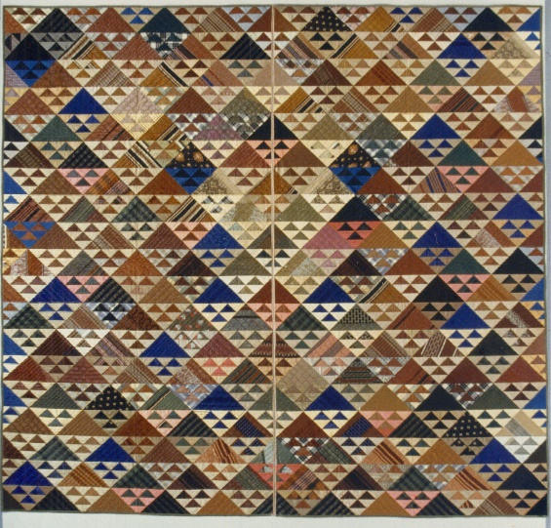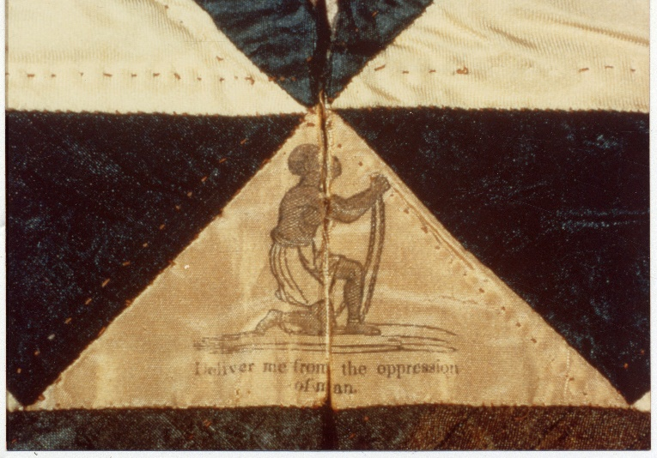

Pieced quilt of silks, cotton batting, glazed cotton back, cut in 2 halves, made by Quaker Deborah Simmons Coates, wife of Lindley Coates (1794-1856). Has 19 horizontal bands of dress silks (many produced by Harmonist Community) in alternating triangles arranged in Birds in the Air or Flying Geese pattern using the template method. Large triangles of varying patterns alternate with large triangles with 3 smaller appliqued triangles of contrasting patterns. Colors are browns, tans, beiges, electric and royal blue, peach and green. Each quilt half has a green silk binding on the three outside edges, and tan silk on the inner vertical cut edge. Quilting patterns are clamshell, diamond, cross in a square and diagonals.

At quilt center is a cream-colored triangle with an abolitionist stamp depicting a kneeling black male slave in chains over the words: "Deliver me from the oppression/ of man." This stamped triangle was cut in two when quilt was divided; image now hidden by modern binding. According to Cuesta Benberry research, this kneeling slave image originated with the English ceramic firm of Wedgwood in the late 1700s. The Wedgwood family were ardent abolitionists, decorating various ceramics with this image, resulting in its rapid adoption by American anti-slavery groups. Used in many forms and media over the years, it remains the logo of the still-existing Pennsylvania Abolition Society and appears on organization's official publications.

Questions to Consider

What statement did Coates hope to make with this piece?